**Volume**

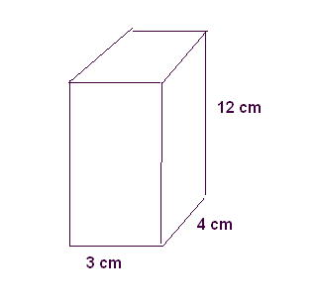It is how many units can fit inside a polygon

1 cm

1 cm

**How to solve for the volume of a rectangle prism**

V= L x H x W

V= 3 x 4 x 12

V= 144 ${cm}^{3}$

**How to solve for the volume of a cube**

V= S x S x S

V= 4 x 4 x 4

V= 64 ${cm}^{3}$

4cm

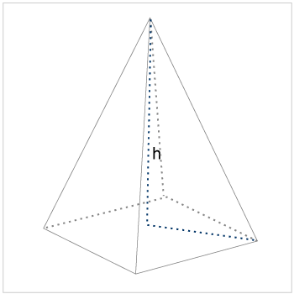

**How to solve for the volume of a pyramid**

V= $\frac{1}{3 }x area of the base x height$

V= $\frac{1}{3 }$ x (2 x 4) divide by 2) x 6 =

V= 8 ${cm}^{3}$

6 cm

4 cm

2 cm

**How to solve for the volume of a cylinder**

V= $r^{2 }x π x h$

V= ${(2)}^{2} x 3.14 x 5$

V= $4 x 3.14 x 5$

V= $20 x 3.14=62.8{cm}^{3}$

V= ${62.8 cm}^{3}$

2 cm

**h**

5 cm

