**Parts of an angle**

**Pairs of angles**

**Adjacent angles**

Have the same angles, sides are connected and vertex

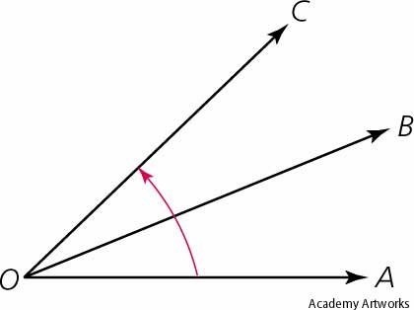

**Vertical Angle**

Formed by two intersecting line. Vertex is parallel to each other

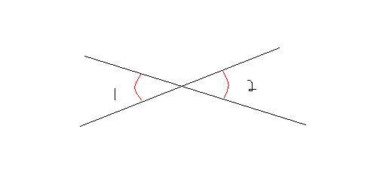

**Complementary Angle**

Two pairs of angle which forms a right angle

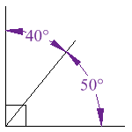

**Supplementary Angle**

Two pairs of angle which forms a straight angle

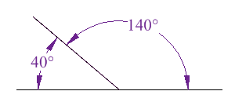

**Angles**

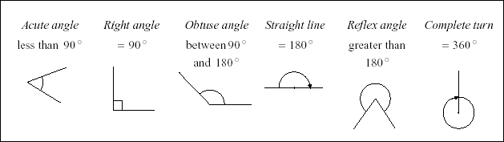 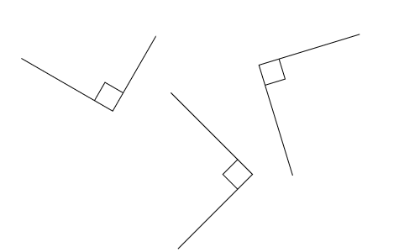

**Types of Angles**

**Ways to name angles (use the angles above)**

**If referring to only one side of the angle**.

Terminal Side – Vertex, Initial Side - Vertex

AC and BC (always use the ray symbol for naming a side)

**If referring to the whole angle**

Terminal Side – Vertex – Initial Side

ACB, (the symbol of an acute angle)

Vertex (always use a number)

1 (the symbol of an acute angle)

C

B

A

1

Initial side: always 0º

Terminal Side

Vertex