Geometry Part III
Angles

Angles Formed By Parallel lines cut by a transversal line
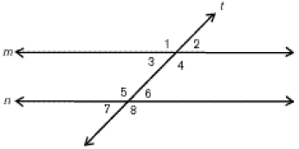
Exterior angles: outside angles
Ex. 1, 2, 7, and 8
Interior angles: inside angles
Ex. 3, 4, 5, and 6
Alternate Pairs: This helps solve for the missing angle. The pair of alternate angles have always the same measurement in vortex.
Alternate pairs are the opposite vertical angles
- Alternate Exterior Angles
Ex. 1 and 8
- Alternate Interior Angles
Ex. 4 and 5
The transversal line: Line segment “t”
Two parallel line: Line segment “m” and “n”

Polygons: a plain straight shape
Triangles
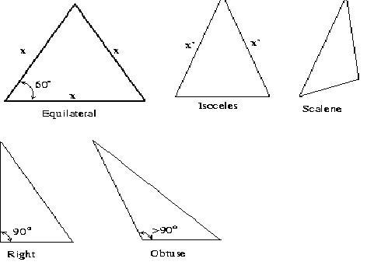
Equilateral: All sides are equal
Iscoceles: Two sides are equal
Scalene: No sides are equal
ANGLE TRIANGLES
Right: has a side with 90º
Obtuse: has a side with an obtuse angle
Acute: all sides are acute (equilateral, isoceles)
Exterior and Interior Opposite Pairs
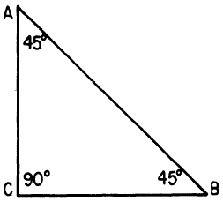
D
All the three interior angles (A,C,B) adds up to 180º
If you add “D” that becomes an exterior angle, ACD is formed
Properties of Quadrilaterals: it is a closed geometric figure bound with 4 line segments
The sum of an interior angle quadrilateral is 360º
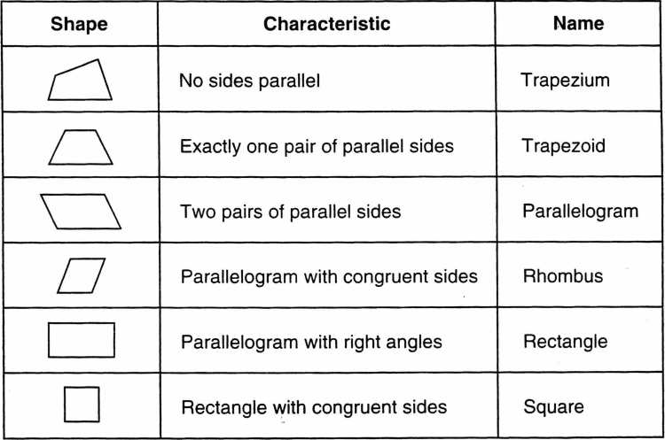
Pythagorean Theorem: Only use this when it is a right triangle
Hypotenuse

5
3
4

Use this to find a side, usually “Hypotenuse”
Equation: $3^{2 }+ 4^{2}= n^{2}$
How to do it:
Get the square of 5 = 3 x 3 = 9
Get the square of 4 = 4 x 4 = 16
Add 16 + 9 = 25
25 is the square of the missing number. So get the square root of 25.$\sqrt{25}$
Getting the square root is 5

